Linux kernel booting
In this Article we will be discussing about linux kernel booting process. We will go step by step to have a deep knowledge of Linux kernel booting. Linux kernel booting process which we are discussing is basically related to linux kernel booting in embedded devices but linux booting is almost similar in PC also.

Linux kernel booting is divided mainly into three stages.

1) System Startup
2) Bootloader
3) Linux kernel execution

We will going in each stage of linux booting and understand it deeply.
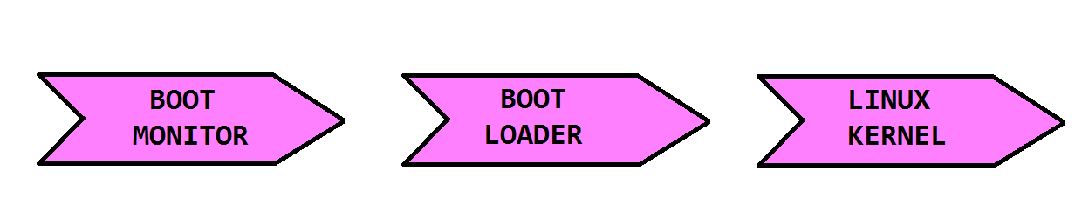
1) System startup
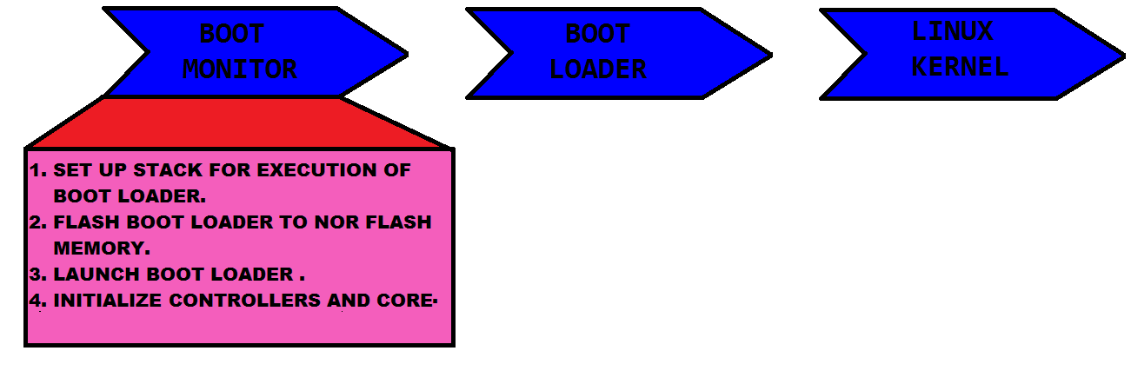
1)User press the power button or reset the device.
2)CPU fetches first instruction from Reset vector .
3)Reset vector is the address which contains the first instruction to be executed after press the power or reset button.
4)Value of Reset vector is provided by OEM vendor of device.
5)Generally this address exist in NOR flash memory where the execution of boot monitor code starts.
6)Boot monitor is the small program which exist in Nor memory and shipped with Board similar to BIOS in PC.
7)Boot monitor code initialize main memory controller.
8)Setup stack in memory for the execution of bootloader.
9)Flash u-boot or other bootloader to NOR flash Memory.
10)Launch U-boot or other boot loader from boot monitor command line or can be done manually by entering command on boot monitor prompt.
11) If internal static RAM of Device or board is so small and cant store full bootloader then boot loader is devided into two parts first stage boot loader and second stage boot loader.
12) Then instead of loading full boot loader Boot monitor code loads only first stage boot loader.

2) Bootloader
If boot loader is divided into two stage then first stage boot loader initialise the core, Cache memory and then load second stage boot loader.
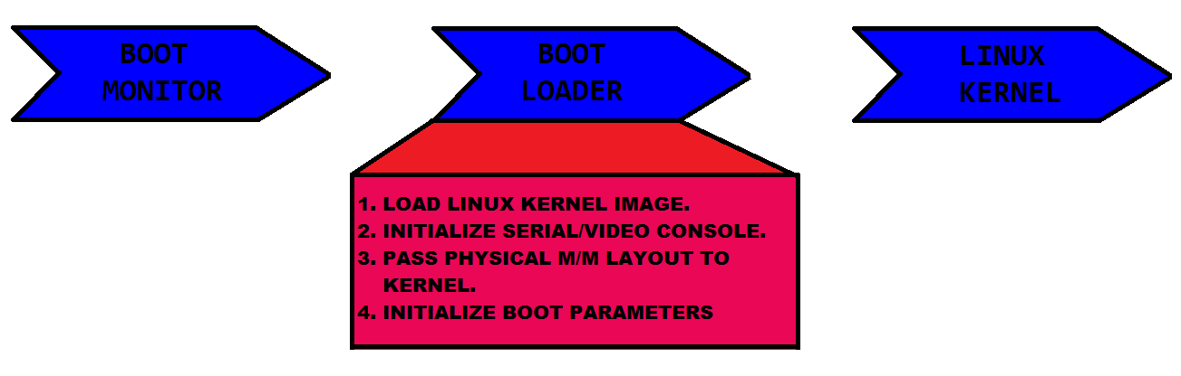
Second stage boot loader setup C environment for the execution of linux kernel.
Configure the system main memory.
Loads the Linux kernel image from a pre specified location.
3)Initialise Serial or video console for kernel.
4)Passes Physical memory layout to kernel by using booting ATAGS command ATAGS_MEM.
Generally linux kernel loaded at address 0x7cf0 in main memory.
Initialise boot parameters to passing to kernel in form of tags to describe the task it has done till now.
Pass control to kernel.

3) Linux kernel execution
Jump to head.s file which exist in /arch/arm/boot/compressed/head.S for ARM Processor.
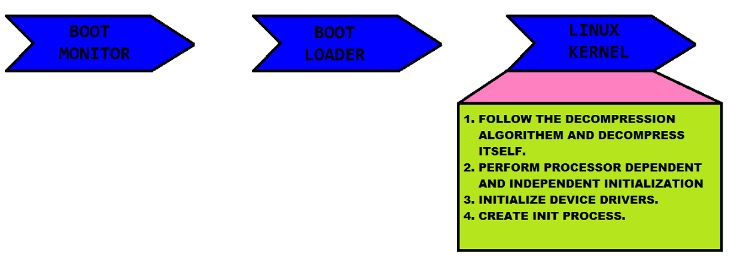
Kernel follow the decompression algorithm and decompress itself as we had compressed image in memory.
After decompressing of kernel , it is responsible to perform some further initialisation activities.
This initialisation activity is divided into two stage.
In first stage kernel perform processor dependent initialisation e.g
lookup for processor type,machine type
Create page tables
Initialise TLB, Cache, MMU
finally it jumps to start_kernel() routine init/main.c where actually linux kernel starts.
After that kernel does second stage initialisation which perform processor independent tasks.
Initialise kernel tick control
set-up per cpu stack
Initialise memory zones such as DMA , High memory, low memory etc.
Initialise the interrupt tables
Initialise and run the system timer.
initialisation slab allocation
initialise the proc file system.
calls rest_init() function which creates first process which has PID 1.
After all this initialization it does basic setup like driver_init(), network socket interface setup, sysctl interface and calls do_initcalls() which initialise built-in device drivers.
after all kernel level initialisation it calls init_post() in which we actually switch to user mode by calling following processes
run_init_process(“/sbin/init”);
run_init_process(“/etc/init”);
run_init_process(“/bin/init”);
run_init_process(“/bin/sh”);
After userspace process creation and initialisation of services we can see the Operating System logo on our screen which confirms that device booting happened successfully.

Process Management
In this chapter we will discuss about the concept of process and concept related to process like thread and how Linux kernel manage process.
Process and Thread:-
Process is a piece of code which is in currently execution. A process also include some resources like signal ,open files and memory sections (code , data , stack , heap ). Kernel has to maintain all these info in proper way and efficient way.
Threads are the lightweight process or we can say a small entity of process which has unique stack, program counter etc. Linux does not differentiate between process and thread. Linux kernel understand a thread as a process and implements process and thread in same way.
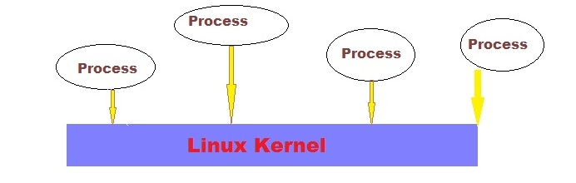
Process Descriptor:-
In Linux kernel a process is represented by Process descriptor which is a structure of type task_struct . Kernel stores all the process by maintaining a doubly linked list in which each node is type of task_struct. In other words we can say kernel maintained a doubly linked list of process descriptors.
The task_struct is a large data structure around 1.7 Kb on a 32 bit machine. This structure maintain all the information about a process. This structure contains info like signals, files ,stack ,state and much more as we can see below picture.
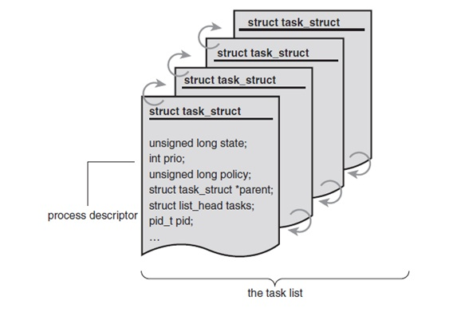
Process descriptor allocation:-
The tast_struct is allocated by slab allocator. Prior to kernel 2.6 the task_struct is stored at the end of process kernel stack. Now the new structure thread_info is dynamically allocated by slab allocator which also leaves at the end of kernel stack of a process.
struct thread_info {
struct task_struct *task;
struct exec_domain *exec_domain;
__u32 flags;
__u32 status;
__u32 cpu;
int preempt_count;
mm_segment_t addr_limit;
struct restart_block restart_block;
void *sysenter_return;
int uaccess_err;
};
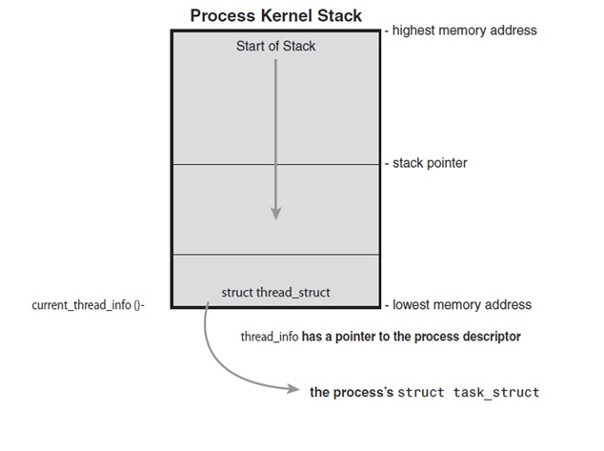
Process descriptor and kernel Stack
the system identify process by a unique identification value or PID which is of type pid_t which is an int. The kernel stores each value as pid in process descriptor. In Kernel code that deals with the process use the task_struct structure to manipulate the process and we can refer to the currently executing process by current macro.
Process State:-
the state field of process descriptor identifies the current situation of process. In linux a process can be in one of the following state.
1) TASK_RUNNING :-
this state specify that process is either running or in ready state and waiting in runqueue .
2) TASK_INTRUPTTIBLE:-
this condition states that the task is in sleeping state and waiting for some event to occur. When this condition occurs task comes in TASK_RUNNING state.
3) TASK_UNINTRRUPTIBLE:-
this state is similar as previous state but in this state process does not wait for any event to occur.
4)_TASK_TRACED:-
The process is getting traced by another process , such as a debugger.
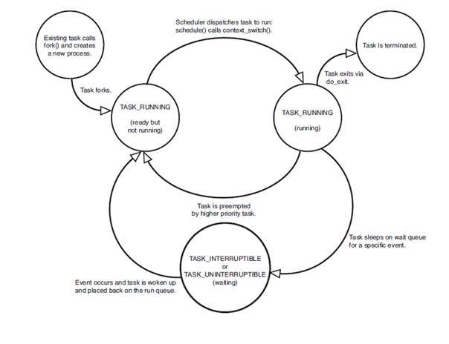
5)_TASK_STOPPED:-
this state states that task is not running and it has stopped the execution.
Process context:-
Normally process runs in user space but when a program calls a syscall or triggers an exception then it enter into the kernel-space at that time kernel is said to be executed on behalf of process and in other word kernel is in “process context”.
The Process Family Tree:-
A tree hierarchy is maintained by Linux between each process. Every process in system has one parent. and a process has zero or more child. Process descriptor contains a member parent which points to the parent of that process and a list of children is maintained by children. So we can traverse the tree and can search the required process.

Top Halves and Bottom Halves
Top Halves and bottom Halves
In last chapter we discussed about Interrupts , how interrupts are handled and registered. In this chapter we will learn what are top halves and bottom halves , what was the limitation of previous implementation of interrupt handler etc.
Limitations On interrupt handler:-
1) It runs asynchronously by interrupting the other code.
2)All interrupt on the current processor disabled.
3)Interrupts are often time critical as they deal with hardware.
4) We cannot block interrupt handler as they run in interrupt context.
Because of all these limitation if our interrupt handling will last for long then our system performance will be less as we won’t able to serve any other request during interrupt handling. So it’s better to shorten the interrupt handling and perform less critical work later.
Interrupt handling is divided into two parts
1) Top Halves:- It is executed as immediate response to interrupt.
2)Bottom Halves:- It is executed some time later when CPU get free time.
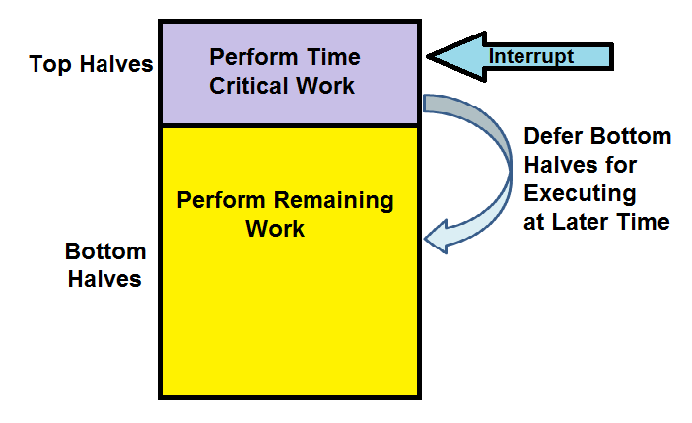

Top Halves:- Top halves executes as soon as CPU receives the interrupt . Following work are generally performed in top halves
1) Acknowledgement of receiving the interrupt
2) copy if some data is received
3) if the work is sensitive needs to perform in top halves.
4)If the work is related to hardware needs to perform in top halves.
5)If the work needs to be ensure that another interrupt does not interrupt it , should be perform in interrupt handler.
Everything else is performed in bottom halves . Lets understand Bottom halves in details
Bottom Halves:- Job of bottom halves is to perform the left out work that was not performed by the interrupt handler or top halves. After bottom halves complete their work, It schedule bottom halves for the later time in future whenever our system will be ideal With the time various techniques of bottom halves evolved . Following are types of bottom halves.

1) Original “bottom Half”
2)Task Queues
3) Softirq
4)Tasklets
5)workqueus
Lets discuss each types of bottom halves in detail
Original Bottom Half
It was the old mechanism in the Linux which provide 32 statically created list of bottom halves for the entire system. Top half could mark weather the bottom half would run by setting a bit in 32 bit integer. Each bit was globally synchronized . No two could run at the same time even on same different processor.
Task Queues
It was a replacement for BH mechanism. The kernel defined a family of queue. Each queue contained a link list of functions to call. Queued function were run at certain times, depending on which queue they were in. Drivers could register their bottom halves in the appropriate queue .

Top half v/s Bottom half
Top Halves and bottom Halves
In last chapter we discussed about Interrupts , how interrupts are handled and registered. In this chapter we will learn what are top halves and bottom halves , what was the limitation of previous implementation of interrupt handler etc.
Limitations On interrupt handler:-
1) It runs asynchronously by interrupting the other code.
2)All interrupt on the current processor disabled.
3)Interrupts are often time critical as they deal with hardware.
4) We cannot block interrupt handler as they run in interrupt context.
Because of all these limitation if our interrupt handling will last for long then our system performance will be less as we won’t able to serve any other request during interrupt handling. So it’s better to shorten the interrupt handling and perform less critical work later.
Interrupt handling is divided into two parts
1) Top Halves:- It is executed as immediate response to interrupt.
2)Bottom Halves:- It is executed some time later when CPU get free time.
Top Halves:- Top halves executes as soon as CPU receives the interrupt . Following work are generally performed in top halves
1) Acknowledgement of receiving the interrupt
2) copy if some data is received
3) if the work is sensitive needs to perform in top halves.
4)If the work is related to hardware needs to perform in top halves.
5)If the work needs to be ensure that another interrupt does not interrupt it , should be perform in interrupt handler.
Everything else is performed in bottom halves . Lets understand Bottom halves in details
Bottom Halves:- Job of bottom halves is to perform the left out work that was not performed by the interrupt handler or top halves. After bottom halves complete their work, It schedule bottom halves for the later time in future whenever our system will be ideal With the time various techniques of bottom halves evolved . Following are types of bottom halves.

1) Original “bottom Half”
2)Task Queues
3) Softirq
4)Tasklets
5)workqueus
Lets discuss each types of bottom halves in detail
Original Bottom Half
It was the old mechanism in the Linux which provide 32 statically created list of bottom halves for the entire system. Top half could mark weather the bottom half would run by setting a bit in 32 bit integer. Each bit was globally synchronized . No two could run at the same time even on same different processor.
Task Queues
It was a replacement for BH mechanism. The kernel defined a family of queue. Each queue contained a link list of functions to call. Queued function were run at certain times, depending on which queue they were in. Drivers could register their bottom halves in the appropriate queue .

Kernel synchronization

Understanding Kernel Synchronization
If a resource is being shared between multiple process at same time then we need to provide protection from concurrent access because if two or more thread will access and manipulate the data at same time then thread may overwrite each other’s changes or access the data while it’s in an inconsistent state. The process of maintaining multiple access to shared data at same in safe manner is called synchronization .
In this chapter we will discuss what is synchronization , why it’s needed, what is critical region and race conditions ,what is deadlock. In next chapter we will discuss various synchronization techniques available in Linux Kernel.
Critical Region and race conditions
Piece of code which access the shared data is called critical Region or critical section . If multiple process execute this code at same time then there might be chances of inconsistency of data. Hence System programmer need to ensure that two or more process should not execute critical section at same time. When two or more threads executing same critical section at same time is called Race condition. So to avoid race condition we need to use synchronization . Now let’s understand with example that why we need protection
Consider a global integer variable i and a simple critical section which tries to increment the variable. Let’s assume two thread A and B tries to enter in critical section at same time and initial value of i is 5. Below is the expected operation
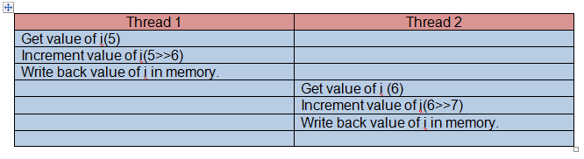
according to the expected execution 5 is incremented twice and the result value of i is 7. As two threads are executing in critical section at same time then there might be chance of below execution
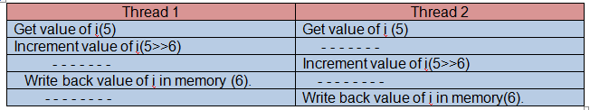
as we can see in above image thread 1 and 2 modified the same variable i at the same time , there might be outcome that result value of i will be 6. This is one of the simples example of a critical region and hence the outcome of it’s also less harm full. But in kernel we might come across very danger situation which can also effect performance of system. So to avoid these kinds of problem , programmer need to restrict simultaneous access of critical region by multiple process. One possible solution of above problem is to performing reading , incrementing and writing back value to memory in a single instruction as below
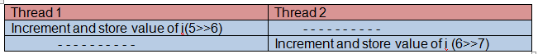
Atomic operation are special operation in which processor can simultaneously perform multiple operation like read and write etc in same bus operation . Atomic instructions are supported by all the processors. But by only usage of atomic operation , our problem of race condition doesn’t get solve in every case. Let’s see little complex example.
Assume some kernel buffer which contains some important data. This buffer is modified or filled by some producer process A and data is read or taken by consumer thread B . If any time producer is updating or manipulating the buffer at the same time when consumer thread is reading the buffer then there are chances of inconsistency of data . By using the above discussed atomic operation solution we cannot avoid critical section in this case. We need to find out a different solution in which can restrict a processor to read and another processor to write at same time.
One way is needed which make sure that only one thread can manipulate the data structure at a time. one mechanism for preventing access to a resource while any other is in critical section and accessing that resource is lock.
A lock works like a lock on door and room behind the door is critical section . If a process tries to enter in the room the while room is empty then that process gets permission to enter in the room and lock the door from inside. Perform its task inside the room and after finishing the work , it leaves the door and unlocks the door. If another process tries to enter in the room while room is already occupied by some other process then it must wait for the thread inside to exit the room and unlock the door before it can enter.
example
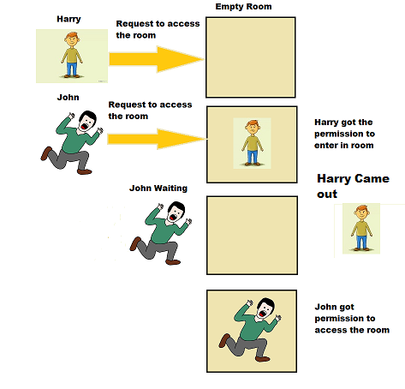
above problem of buffer can be solved by using of lock. Any thread which wants to read or write the first it has to get the lock for accessing the buffer. If lock is granted then only process can access the buffer otherwise thread has to wait till the time when lock is available .Linux kernel provide different way of locking mechanism. we will discuss various kinds of mechanism provided in next tutorial.
Cause of concurrency
In linux kernel there are various reason for concurrency to occur
1)Kernel Preemption
As Kernel got preemptive after 2.6 version . It means one thread can preempt another task. The task which is newly scheduled might be executing in same critical region.
2) Interrupts
As interrupt occurs asynchronously any time , which interrupt the execution of current task.
3)softirqs and tasklets
The can raise or schedule a softirq or tasklet any time, interrupting the currently executing process.
4) Symmetrical multiprocessing
Two or more processor can execute same kernel code at same time which can cause race condition.
5)Sleeping
A task in kernel can sleep any time and ask kernel schedule to schedule new process.
Before writing code developer should indentify all the possible cause of concurrency . If all the reason of concurrency well known then its very easy for Kernel developer to avoid the race conditions.

Knowing Which data to need protection
Developer has to identify which part of data need protection . Generally its very easy to identify the data which needs protection . All the local variable which are specific to some particular thread they don’t need any protection. But all the global variable which can be accessed by other processes also needs to be protected . Below are the other possible data which needs to be protected
1) Data shared between process context and interrupt context
2) Data shared between currently executing process and new scheduled process who preempted the currently executing task
3) Function or code which can be executed by two or more processor at same time.
Deadlocks
Deadlock refers to a situation in which two or more threads are waiting for each process to release a resource . Because of which neither of process get chance to proceed further as the resource for which all the process are waiting will never be available .
For example if a process tries to acquire a lock which its already hold will result a deadlock. As process will never release the previously held lock as its waiting for other lock to acquire.
There are various techniques of avoiding the deadlock. We will discuss deadlocks and various method of avoiding deadlock in other tutorial.

Memory Managment
Memory management subsystem is one of the most complex and at the same time most important part of any kernel. In this article we will discuss about basics of memory management.
Describing Physical memory
To better understand the memory management in Linux, we should know little bit of NUMA and UMA architectures. In this section we will discuss about how memory is organized in NUMA based system from both hardware and software point of view.
NUMA – Nodes and Zones
In brief a NUMA system is a computer platform that comprises multiple components or assemblies each of which may contain zero or more CPUs, local memory, and/or IO buses. It is referred by a ‘cell’. The cells of the NUMA system are connected together with some sort of system interconnect. In NUMA system all memory is visible to and accessible from any CPU attached to any cell.

In Linux, the system’s hardware resources are divided in to multiple software abstractions called “nodes”. Linux maps the nodes onto the physical cells of the hardware platform. As with physical cells, software nodes may contain zero or more CPUs, memory and/or IO buses. And, again, memory accesses to memory on “closer” nodes will generally experience faster access times.

For each node with memory, Linux constructs an independent memory management subsystem, complete with its own free page lists, in-use page lists, usage statistics and locks to mediate access. In addition, for each memory zone Linux construct a DMA zone, a NORMAL zone or a HIGHMEM zone and each is suitable for different type of usage.

Keep in mind that memory can be requested from anyone of the zones and for this Linux kernel provides various flags which kernel developer should pass when calling kernel interfaces.
Page and Page Frame
Page Frame
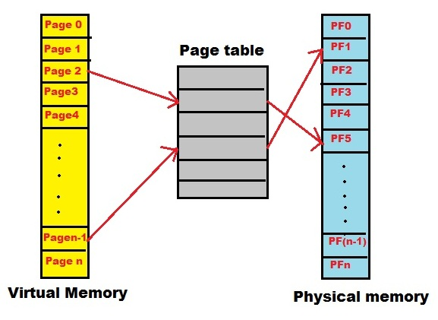
The system’s memory is broken up into fixed sized chunks called page frames. This page frame is treated as the basic unit of memory management unit (MMU, the hardware that manages memory and performs virtual to physical address translations).The kernel represents every page frame on the system with a struct page structure. Please note that each architecture can defined its own page size.
The important point to understand is that the page structure is associated with physical pages, not virtual pages. This page structure’s goal is to describe physical memory not the data contained in it.
Page
The virtual address space is divided into pages, a contiguous span of addresses of a particular size. The pages are page aligned in that the starting address of a page is a multiple of the page size.
Allocating physical pages
Now we will discuss about the interfaces provided by Linux kernel to allocate and free physical pages. Note that interfaces that we discuss below allocates memory with page-sized granularity.
The core function sare
struct page * alloc_pages(gfp_t gfp_mask, unsigned int order)
This allocates 2order (that is, 1 << order) contiguous physical pages and returns apointer to the first page’s page structure; on error it returns NULL.
If you require one page then below API’s are used and which behaves same as alloc_pagesfunction:
struct page * alloc_page(gfp_t gfp_mask)
If struct page is not required, you can directly call below function which returns logical address of the first requested page.
unsigned long __get_free_pages(gfp_t gfp_mask, unsigned int order)
Above function returns more than one page. If single page is required you can use:
unsigned long __get_free_page(gfp_t gfp_mask)
Getting zeroed Pages: If you need the page filled with zeros, use the function
unsigned long get_zeroed_page(unsigned int gfp_mask)
Above allocation requests can fail, so the kernel must check the result returned after every allocation attempt.
If you notice all the above functions expect an unsigned int gfp_maskas an argument. This flag determines how the allocator will behave. gfp_mask is required because different users will require memory from different zones which depends on context user code will run. For example ZONE_DMA is specified while writing certain device drivers or ZONE_NORMALfor disk buffers and callers should not have to be aware of what node is being used. So the gfp_mask helps the allocator to examine the selected zone and checks if it is suitable to allocate pages based on the number of available pages. If the zone is not suitable, the allocator may fall back to other zones.

There is one more function, where given the page it will return the logical address:
void * page_address(struct page *page)
Freeing Pages
void __free_pages(struct page *page, unsigned int order)
void free_pages(unsigned long addr, unsigned int order)
void free_page(unsigned long addr)
As the rule, free only pages you allocate, otherwise kernel can panic or corruption can happen.
vmalloc and kmalloc
kmalloc
The kmalloc is a kernel function used to obtain kernel memory in byte-sized chunks. If we need whole pages, then we have to use function mentioned in previous section.
void * kmalloc(size_t size, gfp_t flags)
Return values:
On success: It returns memory at least size bytes in length.
On failure: Returns NULL.
So we have to check for return value after a call to kmalloc.
kfree
void kfree(const void *ptr)
This method will free block of memory allocated by kmalloc.
gfp_mask Flags
We have seen that the low level page allocators and kmalloc expect gfp flags as a parameter. We will discuss about these flags further and conclude this article.
Here gfp stands for – get free pages and these gfp flags are formed using various other flags. Here our knowledge of zones will come in to picture.
The gfp flags are broken up into three categories: action modifiers, zone modifiers, and types.
Action Modifiers:
Action modifiers specify how the kernel is supposed to allocate the requested memory. For example various contexts exist where developer needs to use different action modifiers:
- For Interrupt handlers must instruct the kernel not to sleep (because interrupt handlers cannot reschedule) in the course of allocating memory.
- In Process context – process can sleep in the course of allocating memory.
Table -1 Low Level GFP Flags
__GFP_WAIT
Indicates that the caller is not high priority and can sleep or reschedule.
__GFP_HIGH
The allocator can access emergency pools and Used by a high priority or kernel process.
__GFP_IO
Indicates that the caller can perform low level IO.
__GFP_FS
The allocator can start filesystem I/O.
__GFP_HIGHIO
Determines that IO can be performed on pages mapped in high memory.

Zone Modifiers
Zone modifiers specify from which memory zone the allocation should originate. Normally, allocations can be fulfilled from any zone.
Table – 2 Zone Modifiers
Flag Description
__GFP_DMA Allocates only from ZONE_DMA
__GFP_DMA32 Allocates only from ZONE_DMA32
__GFP_HIGHMEM Allocates from ZONE_HIGHMEM or ZONE_NORMAL

Type Flags
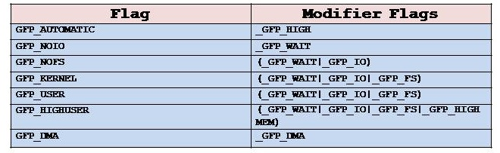

The type flags specify the required action and zone modifiers to fulfill a particular type of transaction.

Table-3 Low Level GFP Flag Combinations for High Level
Flag Modifier Flags
GFP_ATOMIC __GFP_HIGH
GFP_NOWAIT 0
GFP_NOIO __GFP_WAIT
GFP_NOFS (__GFP_WAIT | __GFP_IO)
GFP_KERNEL (__GFP_WAIT | __GFP_IO | __GFP_FS)
GFP_USER (__GFP_WAIT | __GFP_IO | __GFP_FS)
GFP_HIGHUSER
(__GFP_WAIT | __GFP_IO | __GFP_FS | __GFP_HIGHMEM)
GFP_DMA __GFP_DMA
Kernel provides various high level flags used according to the context you are calling the kmalloc function:
GFP_ATOMIC
Used to allocate memory in interrupt handlers and other code outside of a process context and it never sleeps.
Interrupts handles are not executing in process context and they cannot call ‘schedule’ function. Also interrupt handles should execute for short period of time and so should not sleep.
GFP_KERNEL
Normal allocation of kernel memory May sleep. This can be used for example, when executing a system call in kernel on behalf of a process. This can block.
GFP_USER
Used to allocate memory for user-space pages; it may sleep.
GFP_HIGHUSER
Like GFP_USER, but allocates from high memory, if any.
GFP_NOIO
GFP_NOFS
AGFP_NOFSallocation is not allowed to perform any file system calls, while GFP_NOIO disallows the initiation of any I/O at all. They are used primarily in the file system and virtual memory code where an allocation may be allowed to sleep.
We will discuss about usage of these flags in other articles. As of now, you have to be aware of these various flags.
vmalloc
It allocates memory which is virtually contiguous and not necessarily physically contiguous. But do remember ‘kmall0c’ will return physically contiguous and virtual contiguous memory.
So if memory is virtually contiguous and physically not, then how virtual memory is mapped to physical memory?
Kernel does this by using page tables. This we discuss later articles.
You may also get a doubt, which is faster in allocating memory? The answer lies in the above discussion.
Since vmalloc use page tables to map the virtual address to physical address, so whenever you access memory allocated using vmalloc, you have to traverse through page table. This is additional overhead compared to kmalloc. So vmalloc should be used where it is really necessary.
void * vmalloc(unsigned long size)
On success: Returns a pointer to at least size bytes of virtually contiguous memory.
On failure: the function returns NULL.
To free an allocation obtained via vmalloc(), use
void vfree(const void *addr)

Introduction To Linux
Introduction to Linux
Linux is a Unix type operating system.
1)1991: Linux kernel was written by Linus Torvalds in six months to overcome the limitation of his 80386 PC.
2)1992: Linux released kernel under GNU general public license.
3)1994: Linux 1.0.0 released.
4)1995: GNU/Linux and free software developing in Internet servers.
5)2002: Many industry start adopting Linux.
6)2015: kernel version 4.0 released.
Linux Main features:
1) Portable
2)Open source
3)Multi-user
4)hierarchical file system
5)Security
6) Memory Protection
7) shared libraries
Linux kernel version scheme
Linux version is released as x.y.z.
1) Development version
• x.y:- release number
• y:- Odd number
• z:- identifies the exact release version number
• Example:- 2.5.54,2.7.56
2) Stable version
• y:- even number
• Example:- 2.2.50,2.4.60
Linux architecture
To protect data and functionality from fault or some unwanted access in Linux, virtual memory is divided into user space and kernel space.
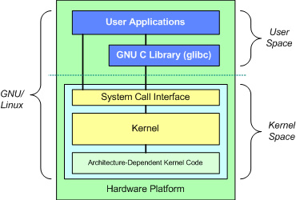
User space:- all the user application runs on User space.
Kernel Space: – Kernel space is the privilege space where mainly operating system kernel and device driver execute.
Gnu C-library: this library expose APIs to user application which helps user application to interacts with kernel by using System calls.
for example in our user space application we generally use printf() which is defined in C-lib and internally calls write() system call.
System Call Interface: System call interface provides the implementation of various System calls.
Kernel: below system call interface we have kernel code which is architecture independent code which is same for all the processor.
Device driver: Device driver is the program which actually interacts controls the hardware’s.

Kernel Configuration and Build
Kernel configuration and build
In Last chapter we have got overview of Linux kernel Architecture and basic subsystems of Linux kernel. Now question arise from where to get the kernel and how to build it.
Download Linux Kernel :-
Linux kernel is open source and maintained by Linux kernel community . Every member of this community keep on working on enhancement of Kernel. This community maintain kernel repository on https://www.kernel.org/ . Every contributor of Linux kernel updates there changes on this mainline kernel so that other can get the update kernel. We can get Latest kernel from this site anytime without paying any charge for it.
Download kernel from:
https://www.kernel.org/
From Kernel.org we get tar file of Linux kernel. So after downloading Linux kernel first job we need to do it untar the Kernel by following command
tar -xvf kernel_name.tar.xz

configure Linux kernel:-
Kernel which we get from Kernel.org is generic kernel which we can build and flash on different hardware platform . But before building Linux kernel we need to customize the kernel or we can say we need to do some platform specific changes to port our Linux kernel on out hardware platform.
For configuring the kernel go into root directory of Kernel’s untar folder and use one of the following way of configuring kernel.
Linux kernel provides us various way of configuring the Kernel. Following are some method to configure the kernel
1) make config
2) make menuconfig
3)make defconfig
make config
make config is a character based questions answers session method in which kernel start asking character based question like whether to enable a particular setting or setting or not. We have to answer according to our requirement.
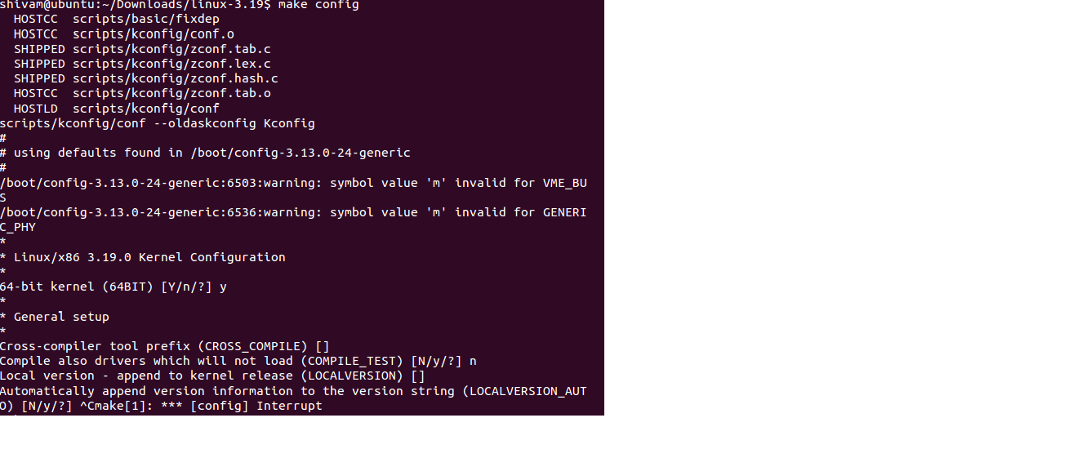
2) make menuconfig
It’s a graphical view of configuring kernel. when we run above command we get a GUI on which we can see multiple kernel settings. For having this GUI we should have ncurses library installed in our system . If we don’t have this installed in our system we might come across following error
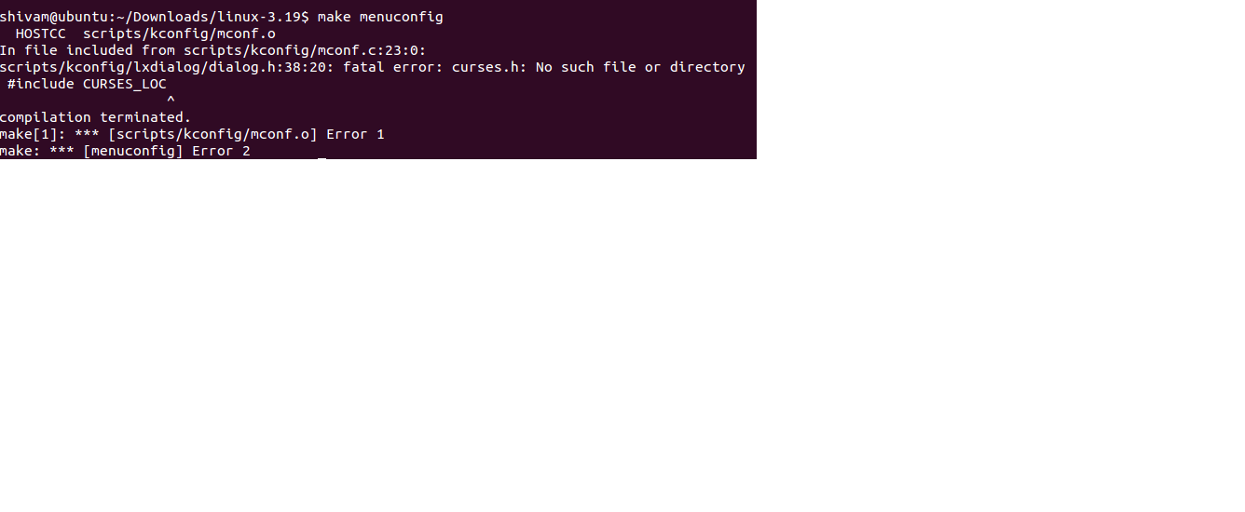

Solution to fix this Error:
download and install following library to fix this issue
- $ sudo apt-get update
- $ sudo apt-get install libncurses5-dev
after doing above step make menu config will run successfully and below screen appear.
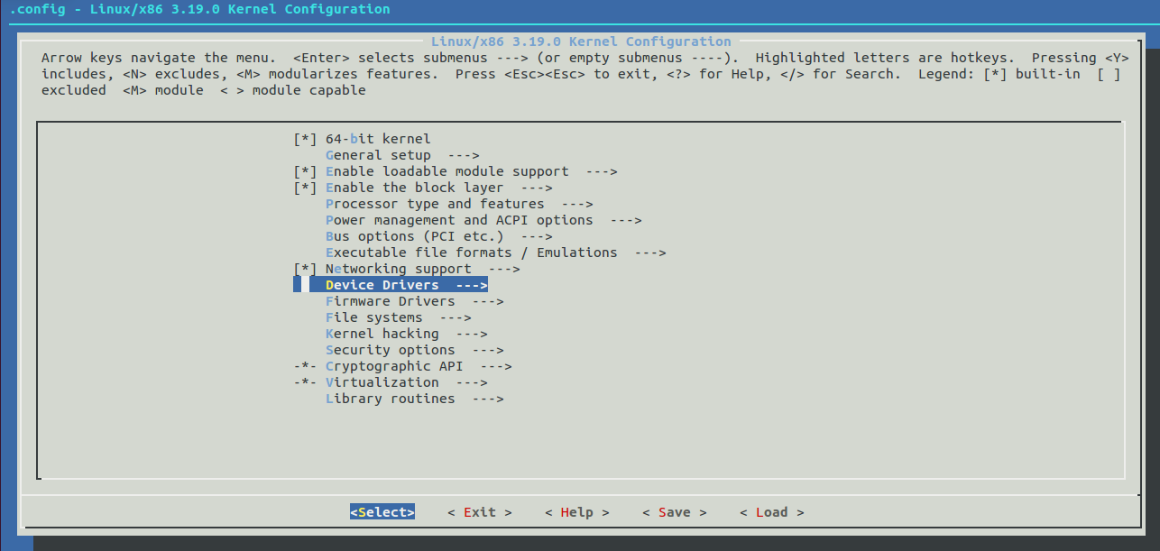

3) make defconfig
When we download kernel form kernel.org , kernel comes with default configuration which is set by kernel maintainer. To create this default configuration give below command
$ make defconfig

Build Linux Kernel
As now we have done the basic setting required for building kernel. Now final step is to build the kernel. Below are the steps to build linux kernel
1) Go to root directory of Untar folder
2) Give Make command
$ make

If our PC has multi core then we can use below command to improve the speed of kernel build.
make -j4
here specify number of cores available present plus 1. by using this command we are forcing to use all the available cores for building the Kernel.

Kernel Subsystems
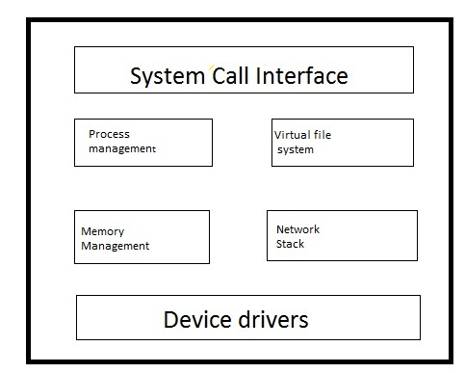
Linux kernel basically composed of following subsystems.
1) Process management
2) Memory Management
3)Virtual file system
4)Network Management
5)System Call interface
1) process management :- This system has the responsibility of maintaining the execution of each process. Main part of process management subsystem is Schedule which control the scheduling or exiting of every process.
2)Memory Management:– This system maintain the system memory and control the memory request from each process. Its manage virtual to physical translation of process. It lies in /linux/mm.
3)Virtual File system :- This subsystem provides the abstraction APIs like open() , Read() and write() etc irrespective of type of file system. User doesn’t need to worry about the file system types. VFS has the responsibility of passing the request of user to respective file system for which the request is raised by user application.
4) Network Stack:- It manage linux IP network or we can say everything related to network is managed by N/W subsystem.
5)System Call interface:- It provides an interface to the applications running in user space for getting the controlled access to hardware. This interface provides a mechanism by which applications can request operating system resources.

Major and Minor number

Every Device in Linux is represented as a regular file. These files are called device files. These device files are located under /dev directory. If you execute ls -l command in /dev directory on Linux terminal you can see list of all the available devices in your system.
These devices are accessed by opening their respective device files. Each device file in Linux has two unique number associated with it. These two numbers are major number and minor number.
Major number is a unique number which specifies a particular driver. Every Device driver has their unique major number which helps kernel to identify the driver . When any application in user space open any device file , kernel check major number associated with that device file and identify which driver is responsible for handling this request. After that any subsequent calls for that particular device is passed to same driver.
A single device driver can handle multiple devices or controllers . For example a single USB driver handles multiple USB ports in your PC or same hard disk driver can manage multiple hard disk. So whenever any request for such kind of devices comes to kernel , kernel has to differentiate between devices or controllers. To differentiate between devices , every device in linux system provided a unique number which is called minor device number. Minor number for example COM port1 in our system has different minor number than COM port2. We can say that Minor number represents a device and major number specify a driver. but one thing is to note here is that Two or more device of same type can have same major number but not minor number.
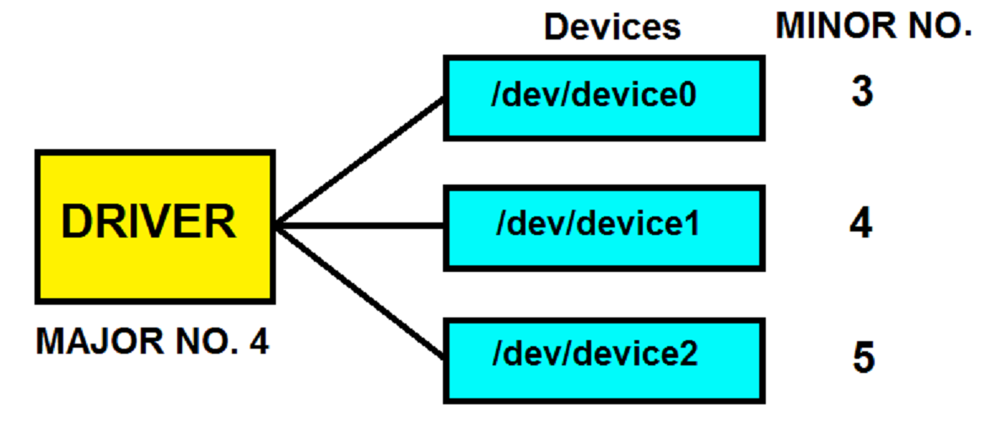
From above image we can see a driver which has major number 4 is handling three devices (device0, device1, device2) having minor number 3,4 and 5.
Internal representation of Major and minor numbers
Kernel use dev_t type which is defined in </linux/types.h> to hold major and minor number.size of dev_t is 32-bit in which 12 bits are used for major number and 20 bits are used for minor number.
Linux kernel also provide below two macros which can be used in our driver to find major number and minor number.
MAJOR(dev_t dev)
MINOR(dev_t dev)
These macros are defined in </linux/kdev_t.h>
Passing Major number in Registration of Driver
in Init function of driver when we register our driver by using of register_chrdev we pass major as one of the argument . below is the syntax of register_chrdev.
int register_chrdev(unsigned int major,const char *name,struct file_operations *fops)
We can choose any number which is not being used till now by any other driver as a major number. If we pass 0 as a major number then kernel will provide any available major number.
You can go through (===>) for having a look on the usage of major number in writing a device driver. In our example we used 90 as major number.

Device Driver Basic structure

Driver Generic structure
Basic structure of driver for every device is similar for every device. We can divide driver structure in following sections.
1) Init and Exit Calls
2) fops structure
3)Interrupt Routine
lets discuss in brief about each section.
1) Init and Exit Calls
As we already discussed that our driver needs to interact with kernel. So driver has to notify to kernel that it also exist in the system. So to notify to the kernel driver has init calls which is used for hooking our driver routines into kernel. Besides notifying or registering with kernel it also allocates any kernel memory required for device and initialize hardware. This function is called at boot time.
In the same way we need to detach our driver from the system when our system is shutting down . To serve this purpose driver use Exit call which is called by kernel at the time of shutting down of system. This call unregister driver or free all the resources it allocated at the time of init call.
static int hello_init(void)
{
printk(KERN_ALERT “Hello world”);
return 0;
}
static void hello_exit(void)
{
printk(KERN_ALERT “Goodby”);
}
module_init(hello_init);
module_exit(hello_exit);
Above example show init and exit calls of driver. module_init() and module_exit() macro is used to tell the kernel that these are the init and exit calls of our driver.
Above init and exit calls doing nothing but printing only Kernel Message.
2) fops structure
This structure defines the capability of our device. suppose if our device supports reading and writing operation then we need to give pointer of reading and writing functions of our driver into this structure.
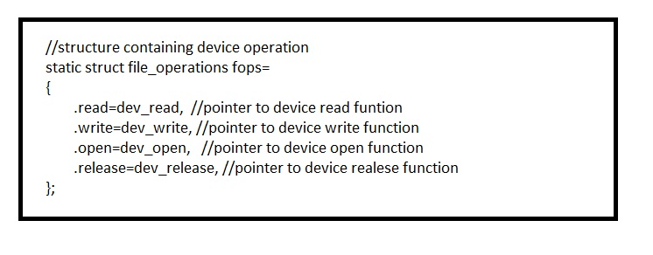

3) Interrupt Routine
If our driver supports any hardware interrupt then we need to define interrupt routine also. This function will be called whenever we will receive interrupt for our device. We need to register the interrupt support in the init function by using request_irq() funtion provided by Linux kernel.
while registering for interrupt we mention interrupt routine which will actual handles interrupt.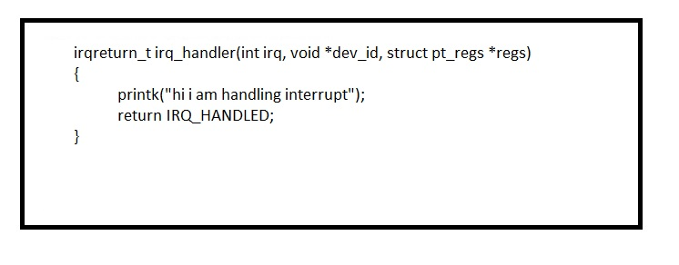

Hello World
“Hello World” driver
In this article we will be writing simple character driver and will hook this character driver in our running kernel of your Linux machine.
As we discussed about multiple component of a character driver. If we put all component together our code looks like below image and save this code as a file name “hello.c”
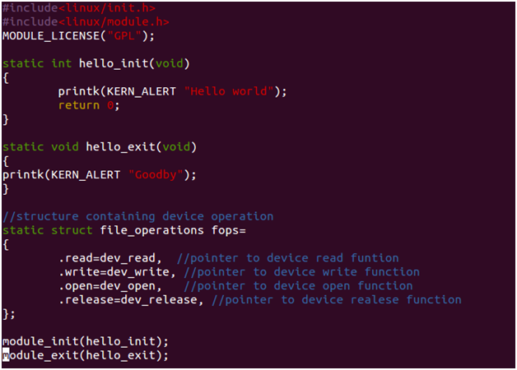
test.c
This is our hello world driver Which at the time of init prints “hello world” and at the time of exit it prints “Goodby”. Now our driver is ready and now we need to build it and hook it with our linux kernel.
Building or compiling driver
We can build our driver with our linux kernel directly by putting your hello.c in any directory of your linux kernel.
we can also build our character driver separately. For that we need to write Makefile which will build our “.c” file. Below is the example of Makefile.
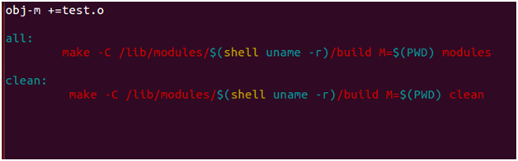
Makefile
put both “test.c” and Makefile in a single directory. Go to the same directory and give make command to build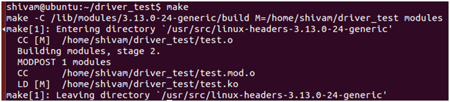
after building driver as an output we get “test.ko” in same directory.

Writing a simple Character Device Driver
In this article we will write a character driver which will support various function like open, close , read and write. In basic character driver structure as we have discussed the components of a driver. following are the steps to write a character driver.
1) write character driver code:- character driver code contains following component
1) Register driver
At the time of init , driver need to register with kernel. We can register driver by following function
register_chrdev (major_number,device,file_operation)
major_ number :- In our driver code we will assume major number is 90 .
device:- device is the name of device for which you are writing the driver. In our character driver we are keeping name of our device is “mydev” .
file_operation:- File operation is the structure which contains the functions supported by your device.
2) unregister driver
At the time of exit our driver needs to be unregister with kernel. We can unregister it by using following function
unregister_chrdev(major_number, device)

3) device functions
Our driver has to implement all the functions supported by our driver. In our character driver we are implementing open, read , write and release function.
Below is the code of our driver . Save this file as test.c
=====================================================================================
#include<linux/init.h>
#include<linux/module.h>
#include<linux/fs.h>
#include<linux/string.h>
#include<asm/uaccess.h>
MODULE_LICENSE(“GPL”);

static char ker_buf[100]; //driver local buffer

static int dev_open(struct inode *inod, struct file *fil);
static ssize_t dev_read(struct file *filep,char *buf,size_t len,loff_t *off);
static ssize_t dev_write(struct file *flip,const char *buff,size_t len,loff_t *off);
static int dev_release(struct inode *inod,struct file *fil);
//structure containing device operation
static struct file_operations fops=
{
.read=dev_read, //pointer to device read funtion
.write=dev_write, //pointer to device write function
.open=dev_open, //pointer to device open function
.release=dev_release, //pointer to device realese function
};
static int hello_init(void) //init function to be called at the time of insmod
{
int t=register_chrdev(90,”mydev”,&fops);
if(t<0)
printk(KERN_ALERT “device registration failed.”);
else
printk(KERN_ALERT “device registred\n”);
return 0;
}
static void hello_exit(void) //exit function to be called at the time of rmmod
{
unregister_chrdev(90,”mydev”);
printk(KERN_ALERT “exit”);
}
static int dev_open(struct inode *inod, struct file *fil)
{
printk(“KERN_ALERT device opened”);
return 0;
}
static ssize_t dev_read(struct file *filep,char *buf,size_t len,loff_t *off)
{
copy_to_user(buf,ker_buf,len);
return len;
}
static ssize_t dev_write(struct file *flip,const char *buf,size_t len,loff_t *off)
{
copy_from_user(ker_buf,buf,len);
ker_buf[len]=0;
return len;
}
static int dev_release(struct inode *inod,struct file *fil)
{
printk(“KERN_ALERT device closed\n”);
return 0;
}
module_init(hello_init);
module_exit(hello_exit);
=====================================================================================
2) Build driver
To build driver we need to write, make file and save it in the same directory where our driver code is save. Below is the example of make file.
save this file as Makefile. Please note that name of file should has M capital.
now give make to build the module.
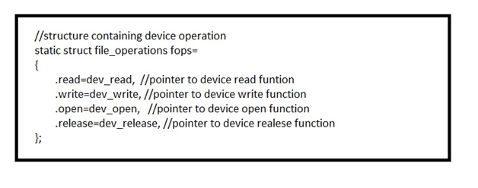
it will generate test.ko file as an output.
3)inserting driver module
We can insert our driver module in kernel by using insmod command.
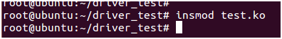
4) make device node
As we know that for user our device is just a file. so we need to create a device node in kernel device tree. Following is the command to create the device node
mknod path type major minor
path:- path is the place where device file needs to be created . Mostly we create our device file under /dev directory. we give same name of device file which we registered at the time registering our driver. As in above code wehad given device name is “mydev”. So we will give path as /dev/mydev.
type:- type will be “c” or “b” . Weather our device will be registered as character device or block device.
major :- Major number of driver. In our case we assumed device major number as 90.
minor:- minor number is defined as minor number of device. we are assuming this value to 1.
after creating node you can see your node by giving following command
cat proc/devices
it will list out all the devices registered in your system.
6) change permission of device
To enables processes to read and write our device we need to change the permission of our device by following command
chmod a+r+w /dev/mydev
our driver is ready now , device node is created . we can test our driver by writing a small user space application which will open our device and will try to write and read to device. Following is the code of our test application
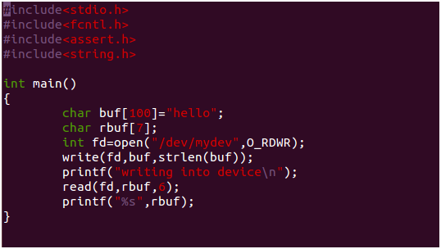
this application is writing hello to device and reading same from device.
save this file as test_app.c and compile this file as we compile other c file.
cc -o test_app test_app.c
execute this file to test the driver by following command.
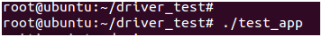

Linux Kernel Module
In this chapter we will discuss about Loadable kernel modules. We will understand what are Loadable kernel modules, why Loadable kernel modules were introduced, what are the benefits of kernel modules, what are the usage of Loadable kernel modules and how Loadable kernel modules are different with user space modules.
When you write some piece of code and want to add that code in kernel , one way of doing this is to place your code in one of kernel source directory and recompile the kernel code . So your code will also compile with whole kernel code. Your code will be part of kernel booting image.
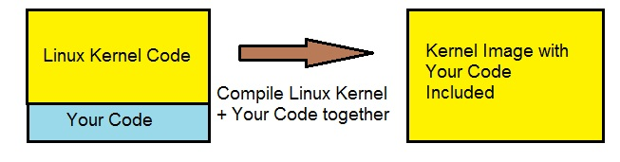
But suppose if you want to do little change in your code then again you need to rebuild your kernel to have your code compiled. So don’t you think it’s a tedious task of recompiling kernel again and again even for just a silly change in your code. To avoid this limitation with many other limitations Linux introduced the concept of Loadable kernel modules.
Kernel module is the piece of code which can be loaded and unloaded into kernel upon demand. it means you can load your code or module into kernel whenever it required and you can unload your code and module from kernel whenever you don’s required.
Kernel modules are compiled separately and whenever there is requirement for that module , you can insert it into kernel by using of some commands. When required work is done by module and no longer required you can easily unload your module by running some commands.
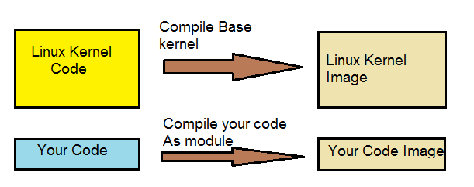
Benefits of Kernel module
- You no need to build whole kernel again just to have a small change in your code. you can change your code , compile it separately and then load into kernel.
- You can easily debug any issue by using modules. suppose you compile code with as part of kernel and after building your kernel is not booting then it’s very hard to find that issue is caused by your code or some other part of kernel. But if you use concept of kernel module then you can first boot your base kernel without your module and see if its booting fine. In case if its booting fine then you can add your module and if after inserting your module kernel got crashed then it means your module is the culprit. You can separately debug the issue in your module.
- When you compile your code as part of kernel , your code will be part of your kernel ‘s compiled image then it will be loaded all the time in memory even though you don’t required it. But kernel module will be loaded only when it will be required and can be unloaded when not required in future.
- Their performance is same as other code which is part of kernel itself.
- You can frequently change your code easily without rebooting kernel.
Usage of Linux kernel modules
Because of so many features provided by kernel modules , are used for various things
- Device drivers:- Device Driver is an interface between User application and Hardware. User application request to Device driver for any interaction to hardware. Device driver check if the application has the permission to access the hardware or not. And depending upon that Device driver of Requested hardware respond.
- file system drivers:- Our system always connected to multiple storage devices. Each device provides different way of accessing data stored in device. These different way of accessing the devices are provided by file system driver.
- system calls:- It provides an interface to the applications running in user space for getting the controlled access to hardware. This interface provides a mechanism by which applications can request operating system resources. If you are implementing your own syscall you can implement it as a module and load in kernel whenever its required.

Kernel Module vs User module
From functionality of loading and unloading of kernel module some time people thinks its same as user modules. But there are lot of difference in both.
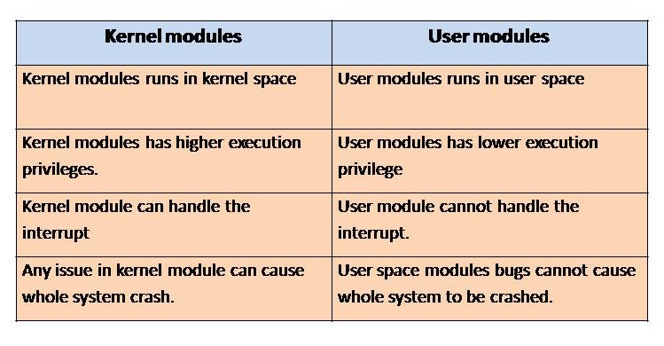

Input output Control
Now we have understood like what is device driver, basic components of device drivers ,functionality of device driver. As we have in almost every driver have basic functions support like open, close , read and write. Besides of these generic function every driver may have their own particular functionality exposed to user space applications. Like driver for display devices may have function to control the brightness and resolution. Driver for camera sensor may have functions to control the image resolutions ,starting captures of images and shutting down it.
So there should be some mechanism to call or initiate these functionality from user space. One way of doing this is by using of syscalls . But problem with syscalls was that syscalls are limited in number and with available syscalls we cannot cover all the functionality of every devices available in this world. And the other problem is to remember all the syscalls and there uses.
To solve this problem Linux provide us a generic call which can be used to control any device which is called IOCTL or input output control. As the name suggest by using of ioctl we can write to the device as well as we can read from the device also.
Now let’s understand the mystery that how a single generic call can fulfill the requirement of controlling all the devices. for that lets understand ioctl call.
following is the syntax of ioctl call
long ioctl(struct file *f, unsigned int cmd, unsigned long arg);
from above declaration we can understand that command and arguments are the main component for ioctl.
command :- command specifies the operation that need to be performed on the devices.
arguments :- these are the parameter which actually required to fulfill the command or we can say these are the configuration parameter if we are trying to configuring the device. If there is need to send more than one argument we can put all argument in a structure and pointer to that structure is passed as an argument. Argument is taken as long integer in kernel space and processed accordingly.
IOCTL implementation in driver
ioctl function needs to be implemented in driver and an function pointer is initialized with it as we do in case of open(), close() etc. In implementation of ioctl we generally use switch case statement ,each case belongs to commends expected from the user space. lets understand it with below example
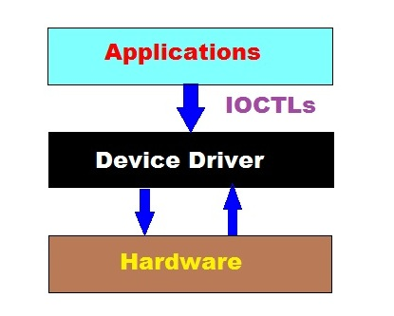
========================================================================
#include<linux/init.h>
#include<linux/module.h>
#include<linux/fs.h>
#include<linux/string.h>
#include<asm/uaccess.h>
//#include<sys/ioctl.h>
#include”driver_ioctl.h”

MODULE_LICENSE(“GPL”);

static char ker_buf[100]; //driver local buffer
static int a;
static int dev_open(struct inode *inod, struct file *fil);
static ssize_t dev_read(struct file *filep,char *buf,size_t len,loff_t *off);
static ssize_t dev_write(struct file *flip,const char *buff,size_t len,loff_t *off);
static int dev_release(struct inode *inod,struct file *fil);
//structure containing device operation
static long my_ioctl(struct file *f, unsigned int cmd, unsigned long arg)
{
switch(cmd)
{
case QUERY_GET_VALUE:
copy_to_user((int*)arg,&a,sizeof(int));
break;
case QUERY_SET_VALUE:
copy_from_user(&a,(int *)arg,sizeof(int));
break;
case QUERY_CLEAR_VALUE:
break;
}
return 0;
}
static struct file_operations fops=
{
.read=dev_read, //pointer to device read function
.write=dev_write, //pointer to device write function
.open=dev_open, //pointer to device open function
.release=dev_release, //pointer to device release function
.unlocked_ioctl=my_ioctl, //ioctl added by me
};
static int hello_init(void) //init function to be called at the time of insmod
{
int t=register_chrdev(90,”mydev”,&fops);
if(t<0)
printk(KERN_ALERT “device registration failed.”);
else
printk(KERN_ALERT “device registred\n”);
return 0;
}
static void hello_exit(void) //exit function to be called at the time of rmmod
{
unregister_chrdev(90,”mydev”);
printk(KERN_ALERT “exit”);
}
========================================================================
In the above example we can see that we have implemented my_ioctl function to handle the ioctl commend from user space . As you can see we have defined three case:-
QUERY_GET_VALUE:- to read the value of variable a from user space.
QUERY_SET_VALUE:- to set the value of a from user space.
QUERY_CLEAR_VALUE:- to set the value of a to 0.
there are the command which user application can send to our driver. So in a conclusion we can say that we need to define the case for every possible command we are expecting to receive from user space.
after defining my_ioctl () we need to initialize the unlocked_ioctl function pointer with the address of my_ioctl.
.unlocked_ioctl=my_ioctl
IOCTL header file
these ioctls command and their arguments are defined in some header file and that header file is included in both user space application and driver.
=====================================================================
driver_ioctl.h
#include <linux/ioctl.h>
#define QUERY_GET_VALUE _IOR(‘q’, 1, int *)
#define QUERY_CLEAR_VALUE _IO(‘q’, 2)
#define QUERY_SET_VALUE _IOW(‘q’, 3, int *)
======================================================================
In the above function definition _IOR, _IOW, _IOWR define the direction of operation.
_IOR:- it indicates the direction from driver to application or we can say it’s a read operation.
_IOW:- it indicates the direction from application to driver or we can say it’s a write operation.
User space application
Below is the application code in which we invoke the ioctl with command and argument.
======================================================================
test_app.c
#include<stdio.h>
#include<fcntl.h>
#include<assert.h>
#include<string.h>
#include<sys/ioctl.h>
#include”driver_ioctl.h”
int main()
{
char buf[100]=”hello”;
int a=10;
char rbuf[7];
int fd=open(“/dev/mydev”,O_RDWR);
ioctl(fd,QUERY_SET_VALUE,&a);
printf(“value written is = %d\n”,a);
a=0;
printf(“lets read value from device\n”);
ioctl(fd,QUERY_GET_VALUE,&a);
printf(“value of a is =%d\n”,a);
}

Module parameters
Module Parameters
In previous chapter we discussed about kernel modules http://www.tutorialsdaddy.com/courses/linux-device-driver/8486-linux-kernel-module/and there features . So when we write any kernel module, we might need to pass some information to module at the time of loading modules And these parameters might vary from system to system. Fortunately Linux kernel provides us the way of providing parameters to module at time of loading module.
We can pass parameters by insmod command . This command accept integer and string values on the command line. suppose your module require an string parameter str and an integer parameter intr , these parameters can be set at load time with n insmod command like
insmod hello.ko str=”hello” intr=50
But before passing any parameters to module, the module must make these parameters available . Linux kernel provide macro module_param() for this purpose. This macro is defined in moduleparam.h. module_param() takes three parameters
1) Name of variable :- These parameters accept variable name which module want to avail at load time.
2) Describing string:- These parameters takes a string which describe the type of module parameter.
3)Permission Mask:- permissions mask to be used for an accompanying sysfs entry.
These macro should be placed outside of any function as we place global variable in any C file.
Above mentioned parameters can be declared as
char *str;
int intr=0;
module_param (str,”s”);
module_param (intr,”i”):
Lets write a simple module in which we will use both of these parameters so that you can understand better.
Below is the source code ( test_module.c) of module which is simple like “Hello world module” (—>) which we discussed earlier except in this module we are declaring two parameters which our module will get at the time of loading .
=========================================================================
test_module.c
#include<linux/init.h>;
#include<linux/module.h>;
#include<linux/moduleparam.h>;
MODULE_LICENSE(“GPL”);
MODULE_AUTHOR(“tutorialsdaddy.com”);
char *str;
int intr=0;
module_param(intr, int, S_IRUGO);
module_param(str, charp, S_IRUGO);
static int hello_init(void) //init function to be called at the time of insmod
{
printk(KERN_ALERT “init function called\n”); //kernel print
printk(KERN_ALERT “value of str is= %s\n”,str); //kernel print to print value of string
printk(KERN_ALERT “value of intr is= %d\n”,intr); //kernel print to print value of integer
return 0;
}
static void hello_exit(void) //exit function to be called at the time of rmmod
{
printk(KERN_ALERT “exit function called”); //kernel print
}
module_init(hello_init);
module_exit(hello_exit);
=========================================================================
Now we can compile this module in the same way as we compiled our “hello world module” by using make command. after compilation we get (test_module.ko) as an output.
Now it’s time to load our module by using insmod command and pass command line parameters to our module. For that you just need to give both parameters values which our module is expecting with insmod command . Following is the example
insmod test_module.ko str=”hello” intr=50
As we discussed in device driver basic component chapter that init function get called at the time of loading of module . So in our example my_init() function of our module will be called which will print both parameters which passed to module at loading time. So you can see below output in kernel logs
string passed is = Hello
integer passed is= 50

MMAP
Linux Device driver MMAP()
We have Discussed Architecture of Linux Operating System (==>) in our previous Linux Device Tutorials . Now You must be knowing that every device in Linux operating system is represented as a Device file . This device file is just like the other files which can be accessed by using file descriptors. Different application which are running in user space might need to access different devices for their own specific purpose. For example camera application will need to access Camera sensor for many things.
Linux Kernel provides various ways of accessing the devices from user space. One way of sending and receiving data to and from user space is by using copy_to_user() and copy_from_user() system calls respectively. We have already seen usage of both these system call in writing a simple driver tutorial(==>). Both of these system calls comes with some extra over head. One overhead is that you have to allocate a buffer in user space buffer also with the kernel buffer. Which is just wastage of extra memory. To overcome these limitations Linux kernel provides a way of mapping the device to some user space address . Mapping a Device means associating a range of user space address to device memory. Whenever the program reads or write in the assigned address range , it is actually accessing the device .
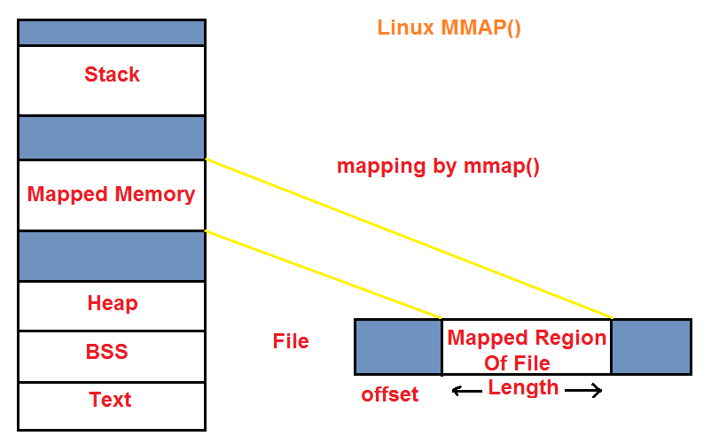
Linux Kernel provides mmap system calls for mapping a device file to user space address range. Lets first understand mmap system call prototype and argument then we will understand mmap usage.
Calls to mmap asks kernel to map len bytes of device represented by the fd , starting at offset bytes into the file , into memory. Below is the prototype of mmap()
void *mmap(void *addr,size_t len, int prot, int flags , int fd, off_t offset );
addr:- Requesting to kernel for starting mapping from this address addr. If address addr is not being used for any other purpose the Linux Kernel start mapping from given address otherwise it will find other available address and return the address as a result of call. If addr value is 0 then you are asking kernel to give any random address.
len:- len is the number of bytes of device need to be mapped.
prot :- this parameter describe the desired memory protection of mapping. Linux kernel provides various pre defined values for this parameters Two most used values are PROT_READ and PROT_WRITE.
PROT_READ:- The pages of memory can be read.
PROT_WRITE:- The pages may be overwritten .
You can know about more flags at http://linux.die.net/man/2/mmap .
flags:- This parameters specifies that any updates to the mapped memory should be visible to other processed mapping the same memory region or not. Various values are defined by Linux kernel for this flags . Below are these values
MAP_SHARED:- This flag value specify to share the mapping with other processes . It means any updates to mapped region of memory will also be visible to other processes that map this file.
MAP_PRIVATE:- Any updates to mapped memory is not visible to other processes mapping the same device or file.
For more flag you can refer http://linux.die.net/man/2/mmap ..
fd:- fd is the file descriptor of the file which needs to be mapped .
offset:- offset in the file from where mapping of file will start.
Please note mmap system call operates on Page basis. hence addr and offset must be aligned as multiple of page size. If the file size is not multiple of page size then remaining memory is zeroed when mapped .
Return Value:-
on success, mmap() returns a pointer to the mapped area. On error MAP_FAILED is returned.
Linux mmap performance
There are various benefits of using mmap as compared to standard read() and write() calls.
1) Reading from and writing to file mapped memory doesn’t need any extra memory buffer but in case of standard read and write we need some extra memory for writing to and reading from user space.
2) It doesn’t include any context witch overhead.
3) mapping a device can be used by multiple process sharing same device .
With the various advantages MMAP also has some limitation
1) If you need to map very large file then it’s very difficult to find contiguous memory available for that size.
2) As this mapping is aligned with page because of this memory can have fragmentation issue.
munmap()
munmap is a linux system call which is used remove the mapping of device which we did by using of mmap system call. below is the prototype of munmap()
int munmap (void *addr, size_t len);
munmap removes the mapped pages located in memory from address specified by addr till length len. If any call made to access the mapping which has been already removed by munmap will cause SIGSEGV signal.
on success munmap() return 0 and on failure it returns -1 and error no is set accordingly.
Linux mmap usage example
As mmap in Linux Kernel is very efficient and easy to use so its obvious to use it heavily in Linux device drivers . Linux Device Drivers generally implement mmap function for providing facility to user space applications to access the device memory. Drivers contain mmap system in the file_operations(==>) structure and and is invoked when mmap system call is used by any application.
struct file_operations my_fops = {
read : my_read,
write : my_write,
open : my_open,
release : my_close,
mmap : my_mmap,
owner : THIS_MODULE,
};
Now Let’s understand Linux mmap usage by writing a simple example. Below is the simple C program which open /dev/mem device and map this device in user space memory by using mmap system call. After mapping device we get pointer to the mapped memory in character pointer data.
By using of this character pointer we can read the data of /dev/mem device. /dev/mem device represents our system main memory. We no need to write driver from ourselves as its already built-in. Please note while accessing the /dev/mem we should not try to write in /dev/mem device as it may corrupt our system memory and can cause system crash. So we should be careful while accessing system memory.
===========================================================================
mmap_test.c
#include<stdio.h>
#include<fcntl.h>
#include<unistd.h>
#include<sys/types.h>
#include<sys/mman.h>
int main()
{
int fd;
char *data;
printf(“starting of program\n”);
fd=open(“/dev/mem”,O_RDWR);
if(fd<0)
printf(“device not opened\n”);
data=mmap(NULL,0x100,PROT_WRITE|PROT_READ,MAP_SHARED,fd,0);
printf(“%p\n”,data);
printf(“%c\n”,data[0]);
printf(“%c\n”,data[1]);
close(fd);
}
===========================================================================
above c program can be compiled in the same way as we compiled other c programs.
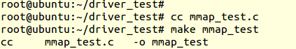
after execution of above c example we can see some random data printed by pointer data.
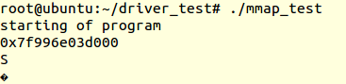

Memory Mapped IO vs Port based IO
CPU connects to multiple external devices like LCD, Hard Disks etc. CPU used for sending and receiving data to/from the devices. Data rate for this transaction might vary from bits to gigabytes .
Process of transaction of data between CPU and Devices, CPU supports multiple ports which are called IO or Input Output. CPU uses these ports for handling multiple devices connected to it.
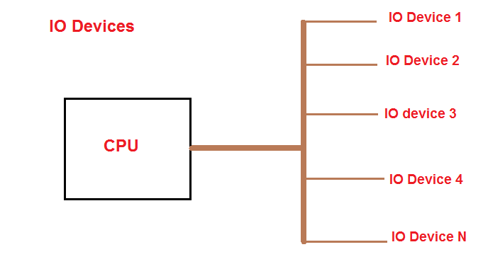
To access any of the external device we need to map that device at some memory address so that it can be accessed by using some standard command. There are two ways available to map the external devices which are specified below:-
1) Port-mapped IO ( PMIO or isolated IO)
2) Memory-Mapped IO (MMIO)
Memory-Mapped IO
In case of memory mapped IO , external devices are mapped to the system memory in the same way as ROM and RAM is mapped . It means devices can be accessed in the same way as we access memory in general scenario. Every instruction which can excess memory can be used to access any IO. No need of having any special set of instruction to access these kinds of IO.

Kmalloc Vs. Vmalloc
Dynamic memory allocation in Device Driver by Kmalloc and Vmalloc
In this chapter we will discuss about memory allocation in Linux device drivers, kmalloc and vmalloc , what are the differences between kmalloc and vmalloc, when to use kmalloc and vmalloc.
While writing device drivers we might need to allocate some memory in kernel space to store some valuable data which can be used for multiple purpose further. Linux kernel provides us various method of allocating memory in kernel space. But following are two kernel memory allocation functions which is majorly used by almost all the drivers.
1) Kmalloc
2)Vmalloc
Kmalloc
Kmalloc is similar to malloc function, we use in our C program to allocate memory in user space. kmalloc allocates memory in kernel space. kmalloc allocates contiguous memory in physical memory as well as virtual memory.
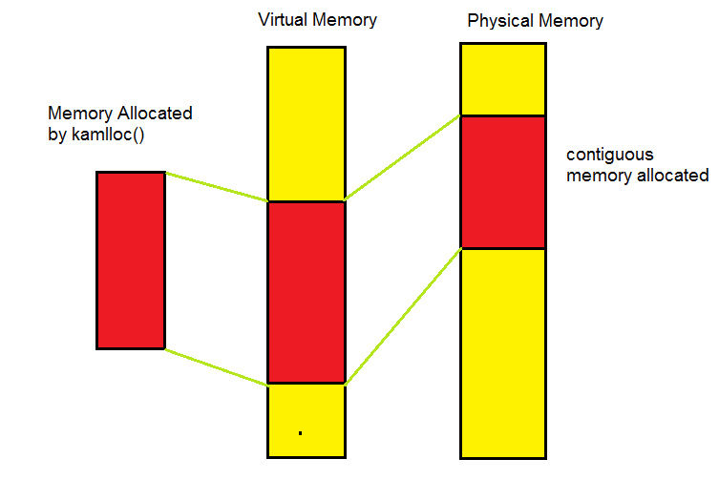
kmalloc is declared in <linux/slab.h>. So if you are using kmalloc call in your driver you have to include <linux/slab.h> file in your driver. Below is the prototype of kmalloc
void *kmalloc(size_t size, int flags);
kmalloc takes two arguments
1)size:- it specify the size of memory to be allocated.
2)flag:- flag argument denotes the behavior of kmalloc call while allocating memory. Linux kernel defined various flags and their different meaning. we will discuss two most widely used flags (GFP_KERNEL and GFP_ATOMIC).
GFP_KERNEL:- use of GFP_KERNEL means kmalloc can put current process in sleep state if memory is low . Hence we cannot use this flag while allocating memory in interrupt handler as we discussed in interrupt handling that we cannot sleep while executing interrupt handler.
GFP_ATOMIC:- GFP_ATOMIC flag ensure that it won’t let current process to sleep if memory is low. So this flag is safe to allocate memory in interrupt handler.
Return value:-
On successful allocation of memory kmalloc return the virtual address of first page allocated. On error it returns NULL.
Kfree()
Kfree function is used to freeing the memory allocated by kmalloc. its declared in <Linux/slab.h> Below is the prototype of kfree();
void kfree(const void *ptr)
It takes address returned by kmalloc while allocation memory as an argument.
Lets understand the use of kmalloc by writing a simple driver which allocates some chunk of memory
=====================================================================
#include<linux/init.h>
#include<linux/module.h>
#include <linux/slab.h>
#include <linux/mm.h>
MODULE_LICENSE(“GPL”);
MODULE_AUTHOR(“tutorialsdaddy.com”);
void *ptr;
static int kmalloc_init(void) //kmalloc_init function to be called at the time of insmod
{
size_t size = 1024; //allocate 1024 bytes
ptr = (void *) kmalloc(size,GFP_KERNEL); //in the kernel segment
if(ptr == (void *) 0)
{
printk(“memory allocation failed\n”);
return 0;
}
else
printk(“Memory allocated successfully\n”);
return 0;
}
static void kmalloc_exit(void) //kmalloc_exit function to be called at the time of rmmod
{
kfree(ptr); //free the allocated memory
printk(“Memory freed\n”);
}
module_init(kmalloc_init);
module_exit(kmalloc_exit);
=====================================================================
Above driver code allocates 1024 bytes of memory in init kmalloc_init() function. you can compile and load this driver in the same way as we tried while writing character device driver(==>)
When to use Kmalloc :-
If memory required in driver needs to be contiguous in physical memory then we have to use kmalloc for allocation of memory.
2)Vmalloc:-
vmalloc is the other call to allocate memory in kernel space as like kmalloc.
vmalloc allocates contiguous memory in virtual memory but it doesn’t guarantee that memory allocated in physical memory will be contiguous.
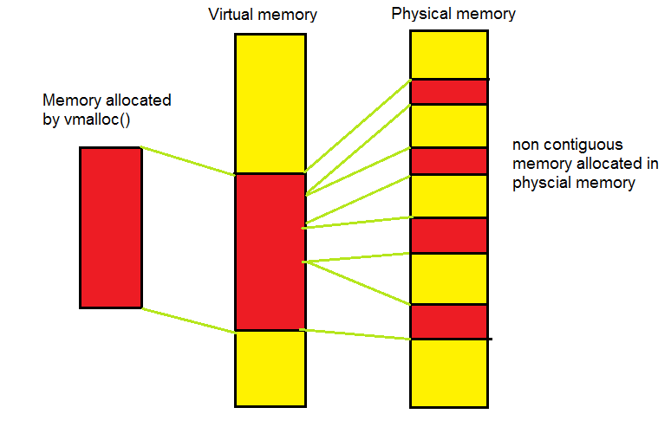
Vmalloc is declared in <Linux/vmalloc.h> . usage of vmalloc call is similar to malloc call. below is the prototype of vmalloc
void * vmalloc(undigned long size).
argument size is the size of memory required to be allocated.
Return value:-
Upon successful allocation of memory it return address of first byte of allocated memory block. On failure it returns NULL.
vfree():-
vfree function is used to freeing the memory allocated by vmalloc(). below is the prototype of vfree().
void *vfree(const void *ptr);
argument ptr is the address returned while allocating memory using vmalloc.
Lets understand vmalloc() by writing a simple driver which allocates 1024 byte of memory using vmalloc().
=========================================================================
#include<linux/init.h>
#include<linux/module.h>
#include <linux/vmalloc.h>
MODULE_LICENSE(“GPL”);
MODULE_AUTHOR(“tutorialsdaddy.com”);
void *ptr;
static int my_vmalloc_init(void) //vmalloc_init function to be called at the time of insmod
{
unsigned long size = 1024; //allocate 1024 bytes
ptr = (void *) vmalloc(size); //in the kernel segment
if(ptr == (void *) 0)
{
printk(“memory allocation failed\n”);
return 0;
}
else
printk(“Memory allocated successfully\n”);
return 0;
}
static void my_vmalloc_exit(void) //vmalloc_exit function to be called at the time of rmmod
{
vfree(ptr); //free the allocated memory
printk(“Memory freed\n”);
}
module_init(my_vmalloc_init);
module_exit(my_vmalloc_exit);
=========================================================================
above driver allocates 1024 byte of memory in init function and free it in exit function.
When to use vmalloc: when you are sure that memory required will never needs to interact with hardware in future or we can if you required memory only for software purpose then we should use vmalloc for allocating memory.
Difference between kmalloc vs vmalloc
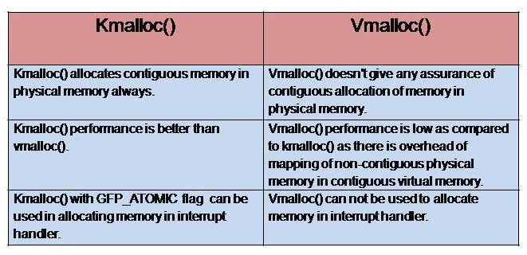

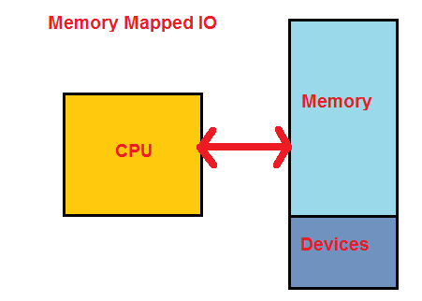
In case of memory mapped IO , IO devices use same address bus as memory. The disadvantage of this approach is that entire address bus needs to be decoded for every device. For accessing these IO address bus will require logic gates to decode the address of device being accessed. It increase the cost of hardware.
Port-Mapped IO
Port mapped IO use different dedicated address space . This address space can be accessed by special instructions which are completely dedicated to access port mapped IO. For example Intel x86 architecture use IN and OUT commands to Read and Write data respectively .Port mapped IO also use the same address bus but might be needed only few lines to access all the available devices . Which means less hardware will require to decode the address of devices and hence less system cost.
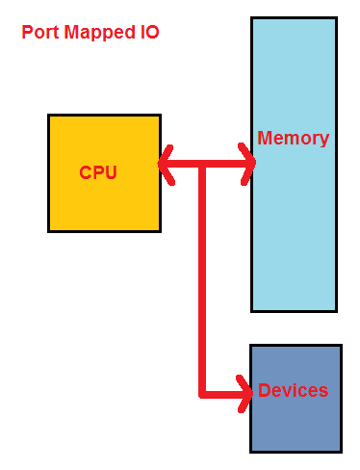
If System has option of Port based IO then its recommended to use Port mapped IO for accessing the devices .This will avoid under utilization of system resources. For example if a system has capacity to access 64K memory and 256 IOs . If we use memory mapped IOs then in that case we need to reserve some memory for IOs and only the left over part can be accessed for general purpose memory. But if you will use port based IO, then you have access to whole 64K memory as well as 256 IOs.
memory mapped IO vs. Port based IO
